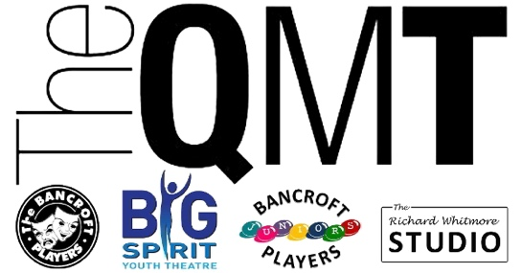

Treasurer’s Report Season July 2020 – June 2021

Dear Members,
The last year for the Theatre has been one of the most challenging we have experienced in a very long time, indeed the effects of the last year have had an impact on most households in some shape or form.
Theatres and venues had to close their doors due to the outbreak of COVID-19 and as such, not only choked the industry but for Societies such as the Bancroft Players, had a significant immediate impact on all revenue streams (including that of membership) without warning.
As a Society we draw on a great number of volunteers, which allows us to manage our finances sparingly, which on this occasion we had indeed been able to do.
Despite closing our doors in March 2020, we limited our immediate outgoings, asked for sabbaticals (where appropriate), and took out cost’s not required, and limited all and any expenditure with immediate effect.
As with all buildings, we needed to continue to tick over, have lighting and heating, manage any maintenance, but all with a joint view that whatever was spent, really needed to be important and essential. I made some immediate changes to policy for approvals and all and every expenditure was approved in a process.
Our largest outgoings very quickly became Utilities and Insurance, which despite requests of support, the respective companies were unable to provide any delayed payments or reduced payment programmes, without a cost to the Theatre.
At the start of 2021, after the third lockdown, we were able to apply for funding grants from various sources to enable to support ongoing costs, and the glimmer that was a possible, a partial re-opening of venues.
The Society was, after many, many applications, successful in a number, with varying degrees of value, but everything helped. We have now concluded what was possible and that has helped significantly balance our outgoings for the 2020-2021, and not only has that funding helped, but it has also provided a stable and solid platform for the Theatre to re-open for the 2021 – 2022 season.
The season ended with the Theatre not going dark, we had the opportunity whilst closed to do as much as we could afford during the time our doors were closed, we took the view that to continue was the most important part of being open again.
As we approach what can only be described as the new normal, we are certainly not out of the wood, indeed our outgoings naturally increase as the doors re-open and as we continue to build lean budgets for productions, we are very mindful that we are still very much impacted by the changes and at any time may again face uncertainty.
As Treasurer I remain committed to managing our budgets, costs and future, whatever that may hold, and hope that our approach and continued focus on costs have supported our ongoing and future existence.

Yours Faithfully

Mark Weatherbed
Treasurer
Bancroft Players Amateur Dramatic Society
Queen Mother Theatre

